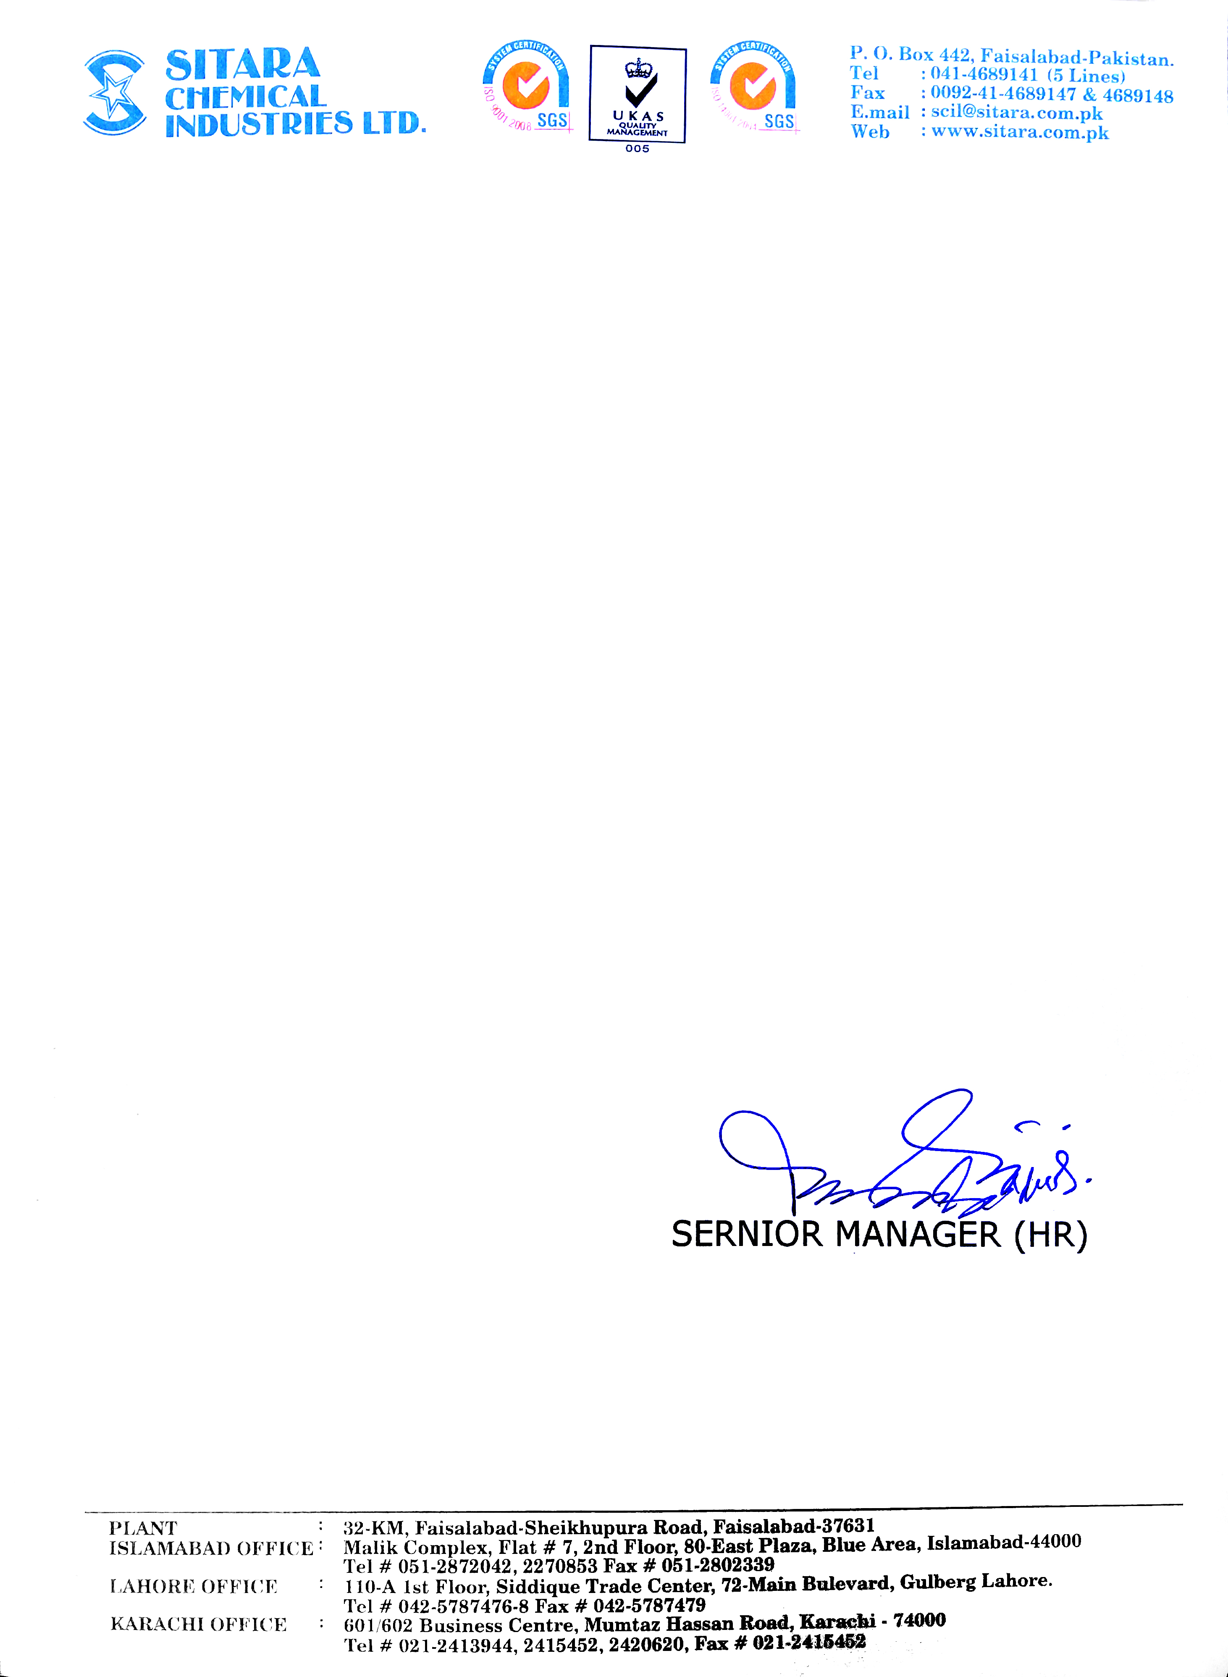

Ref No: _________ Date: <To>

**TO WHOM IT MAY CONCERN**

It is certify that Mr. <Name> S/O Mr. <fname>, who has worked with SITARA CHEMICAL INDUSTRIES LIMITED at Coal Fired Power Plant in capacity of <Designation> from <From> to <To>.

During his time with us: Mr. <Name> has been a dedicated and valuable employee and he has worked hard at all tasks, I have given him. He has always exhibited sound judgment while in my Supervision and he is trusted worker.

He is quick to take initiative and I am very satisfied with his performance. He has been quite helpful in the advancement of our organization.

I wish him all the best of luck in his future endeavors.